**What’s Happening in Rosedale**

**Mystery of the missing TEKWave entry solved**

A number of residents have reported that that they entered visitors into TEKWave, but when the visitors showed up, the gate house had no record of them. On further investigation, it turned out that these folks did not notice that to complete the entry, they had to scroll down to the bottom of the page and click on **SAVE** or **SAVE & SEND E-PASS**.

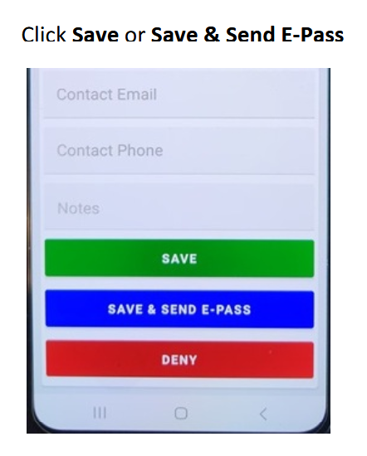

**More Safety Reminders from Rosedale Residents**

When I sent out the email reminding folks to use lights on their bikes and golf carts then driving at night, a number of resident emailed me with more safety tips to share:

**Kids driving Golf Carts** - Children riding golf carts are driving them too fast even faster than the normal person driving a golf cart, laughing giggling and going too damn fast we somehow we need to slow down or we will have an accident. BTW, no one under 16 is allowed to drive a golf cart in Rosedale without an adult supervising,

**Walkers** - Many folks who walk at dusk wear dark clothes are hard to see. People who walk in the road when it’s dark would do well to carry flash light and wear light or reflective clothing? Or better yet, walk on the sidewalk where ever possible.

**Stop Signs** - Another thing to keep in mind is stopping at 3/4 way stop signs—sometimes I see people, especially cyclists, golf carts, and sports cars, just sail through without fully stopping, which can be a bit concerning for others on the road. It would really help if we could all be a little more mindful about road safety to make sure everyone stays safe.

**Progress on the 44th Avenue Extension**

